(Approx. 863 words)

Musings of an Apple Tyro - October
By Lorrin R. Garson, Potomac Area Technology and Computer Society
October 2015 issue, PATACS Posts
www.patacs.org
newslettercolumnist (at) patacs.org

Full System Restore:
Have you ever done a full system restore on your computer? I haven’t had to do this for years, including our use of PC/Windows machines. However… on July 17th it became necessary to do so on our MacBook Pro.

After deleting ~60 GB of files from the MacBook, I discovered none of the space occupied by these files was recovered. Running Disk Utility I discovered numerous file errors on the internal hard drive (actually a solid state drive) with Disk Utility displaying the final message shown in Figure 1. Can you feel the tension rising?
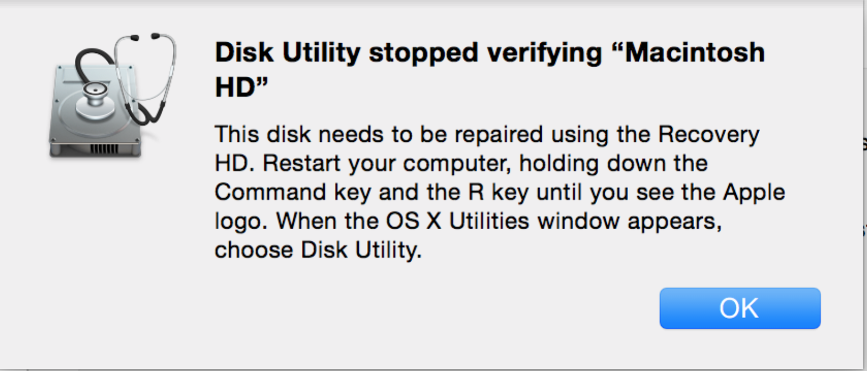
Figure 1

At this point I contacted Apple via https://getsupport.apple.com/ and soon was talking with a support techie who connected to my computer and watched me run Disk Utility again and then said “It would be best to delete everything from your hard drive and do a full system restore from Time Machine. Do you have Time Machine backups?” “Yes”, was my response. This was now sweaty palm time. Wipe the drive lean? Really? The techie walked me through the procedure step-by-step. The process is quite simple: (a) plug in the external Time Machine disk drive, (b) boot up the computer in “Recover Mode” (turn on the power while holding down the Command and “R” keys), (c) select “Restore from Time Machine Backup” and follow the well-described procedures, (d) wait about an hour, and (e) login.

Subsequently everything was back to normal, disk capacity reflected the deletion of 60 GB of files, no file errors, and no lost dat. All was well. Support from Apple was excellent, including a follow-up phone call to ask “is all now okay?”

Security Threat to OS X:
See http://bit.ly/1JNPiAz for an article entitled “Bug in latest version of OS X gives attackers unfettered root privileges”. This article describes a bug in OS X Yosemite (versions 10.10.4 and 10.10.5 [beta]) that makes it possible to infect Macs with rootkits and other types of persistent malware. Version 10.11 (El Capitan in beta) is free of the flaw. To quote from this report “The typical scenario where these types of vulnerabilities are exploited is by developers of malicious applications who want to elevate privileges without prompting end users to enter a system password or by developers of remote exploits that on their own can execute malicious code as a regular user but not as root.”
The original disclosure was made by Stefan Esser at http://bit.ly/1MsQYEt on July 7, 2015. Apple apparently is not going to fix the problem in Yosemite; see http://yhoo.it/1MsR0wj. It would seem anti-malware software will not protect users against this flaw.

There seem to be three solutions to the problem:
- Install SUIDGuard from http://bit.ly/1I6Gbe1. This fix is probably beyond the capabilities of most Mac users.
- Upgrade to OS X El Capitan beta now.
- Wait until El Capitan becomes available for general distribution and install this operating system. El Capitan may be available about the time you read this.

Checking Wi-Fi Networks:
From time to time you may want to check the wireless networks your computer has accessed and keeps track of for future access. If you travel quite a bit you can accumulate an astonishing number of Wi-Fi sites you’ve used, many of which you will probably never access again. To see this information:
- Select Apple from the Menu.
- Click on System Preferences.
- Select Network.
- Click on the padlock in the lower left of the pane and enter your password so that you can make changes. Be careful about the changes you make.
- Click on “Wi-Fi” icon in the left pane of the window.
- Click on the Advanced tab in the lower right of the pane.

A list of “Preferred Networks” will be displayed. Security information about each network will also be shown. Note, when you computer attempts to access a Wi-Fi site it will start from the top of the list.

To delete a Wi-Fi network, highlight an entry and click on the “−“ icon. Entries can be manually ordered by “drag and drop”. Remember to click OK for the changes to be made.

When finished it is prudent to click on the padlock icon to prevent unintended changes.
See https://support.apple.com/kb/PH18525 for information from Apple.

General Information on System Preferences:
Choosing the appropriate System Preferences can make your computer run well and make your computer experiences pleasant. Set the wrong parameters and you can create a nightmare. See http://bit.ly/1LSqVHH for a lengthy discussion entitled “Complete guide to System Preferences in Mac OS X Yosemite to find the best settings for your Mac”.

Uptime:
Want to know how long your computer has been up and running since last booted? Go to Utilities (select Go in the Finder Menu and click on Utilities or search for “Terminal” using Spotlight or key Command+Shift+U), double click on “Terminal” and key “uptime” following by Return. The results are shown in Figure 2 (in this case 2 days, 17:04 hours and minutes). The values for load averages are rather esoteric.


Figure 2

